Lesson 8 Demo 3: Configure a Pod to Use a PersistentVolume for Storage

This section will guide you to:

* Configure a Pod to Use a PersistentVolume for Storage

**Step 1:** Attach a label to the master node in order to assign the pods to it

* Use the following command to add the label to the master node:

*kubectl label nodes <master-node-name> <label-key>=<label-value>*

*kubectl get nodes --show-labels*

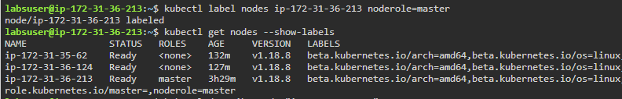

**Step2:** Create an html file on the master node

* Create a **/mnt/data** directory and navigate to it

*sudo mkdir /mnt/data*

*cd /mnt/data*

* In the directory, create an index.html file and test it

*sudo sh -c "echo 'Hello from Kubernetes storage' > /mnt/data/index.html"*

*cat /mnt/data/index.html*

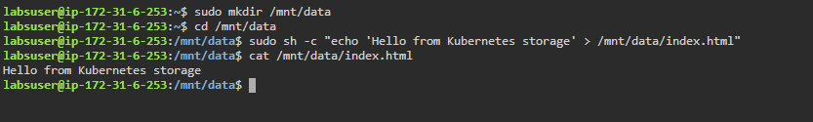

**Step 3:** Create a PersistentVolume for the storage

* Use the following command to create a PV configuration file

*vi storage/pv-volume.yaml*

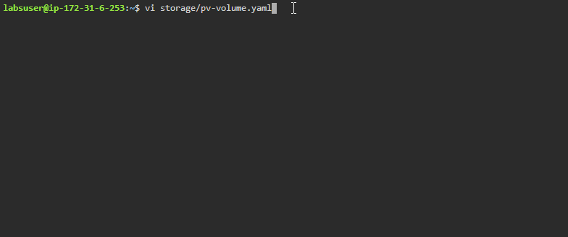

* Add the following code in the **pv-volume.yaml** file:

*apiVersion: v1*

*kind: PersistentVolume*

*metadata:*

*name: task-pv-volume*

*labels:*

*type: local*

*spec:*

*storageClassName: manual*

*capacity:*

*storage: 10Gi*

*accessModes:*

*- ReadWriteOnce*

*hostPath:*

*path: "/mnt/data"*

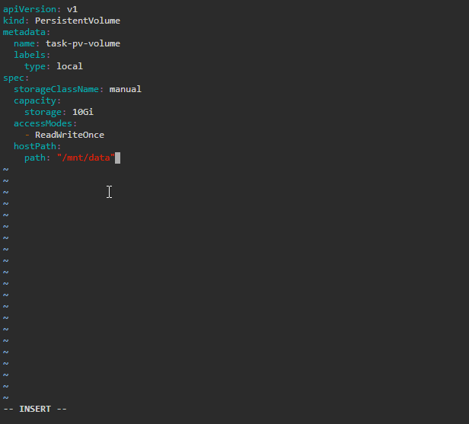

* Use the configuration file to create the PersistentVolume and check the PV volume information

*kubectl apply -f storage/pv-volume.yaml*

*kubectl get pv task-pv-volume*

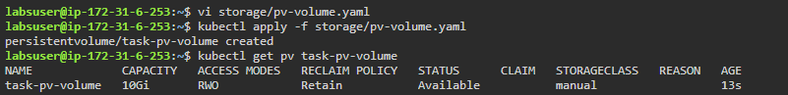

**Step 4:** Create a PersistentVolumeClaim for providing physical storage to a pod

* Use the following command to create a PVC configuration file

*vi storage/pv-claim.yaml*



* Add the following code in the **pv-claim.yaml** file:

*apiVersion: v1*

*kind: PersistentVolumeClaim*

*metadata:*

*name: task-pv-claim*

*spec:*

*storageClassName: manual*

*accessModes:*

*- ReadWriteOnce*

*resources:*

*requests:*

*storage: 3Gi*

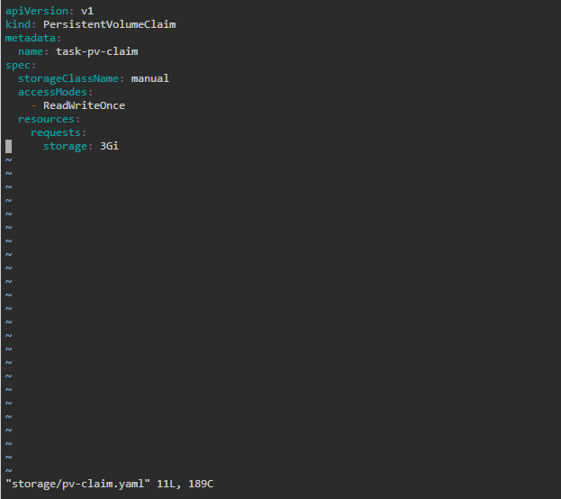

* Use the configuration file to create the PersistentVolumeClaim and check the PV volume again

*kubectl apply -f storage/pv-claim.yaml*

*kubectl get pv task-pv-volume*

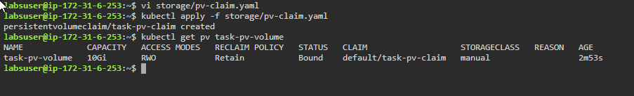

**Step 5:** Create a Pod that uses the newly created PVC as a volume

* Use the following command to create a configuration file for a pod

*vi storage/pv-pod.yaml*



* Add the following code in the **pv-pod.yaml** file:

*apiVersion: v1*

*kind: Pod*

*metadata:*

*name: task-pv-pod*

*spec:*

*volumes:*

*- name: task-pv-storage*

*persistentVolumeClaim:*

*claimName: task-pv-claim*

*containers:*

*- name: task-pv-container*

*image: nginx*

*ports:*

*- containerPort: 80*

*name: "http-server"*

*volumeMounts:*

*- mountPath: "/usr/share/nginx/html"*

*name: task-pv-storage*

*nodeSelector:*

*noderole: master*

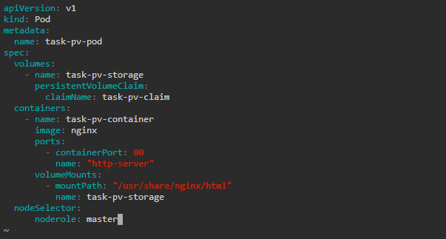

* Use the configuration file to create the pod and check the PV volume again

*kubectl apply -f storage/pv-pod.yaml*

*kubectl get pod task-pv-pod*

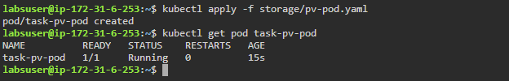

* Use the following commands to execute the container running inside the pod and use storage from the PVC

*kubectl exec -it task-pv-pod -- /bin/bash*

*curl* [*http://localhost/*](http://localhost/)

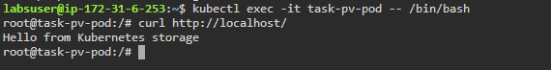

**Note:** Run the following commands if the curl is not installed in root shell:

*apt update*

*apt install curl*